EXHIBITION CATALOGUE FOR “DREAMING OF ANTARCTICA”
RONA MCSEVENY PHOTOGRAPHY
STREET GALLERY, UCLH, 235 EUSTON ROAD, LONDON NW1 2BU
18 JULY TO 4 SEPTEMBER 2019

BUY A PICTURE TO SUPPORT UCLH ARTS AND THE UK ANTARCTIC HERITAGE TRUST

PRICING STRUCTURE  AVAILABLE NEW (Free delivery in UK):  1m x 70cm: £299  70cm x 50cm: £199  60cm x 40cm: £149  40cm x 30xm: £79  EX-DISPLAY DISCOUNT: See Below for individual prices. | SALES CONTACT  LAURA BRADSHAW  email: laura.bradshaw7@nhs.net  teL: 020.3447.7146
ALL IMAGES PRINTED ON LIGHTWEIGHT ALUMINIUM AND READY TO HANG

IMAGE | REF | TITLE | IMAGE | REF | TITLE
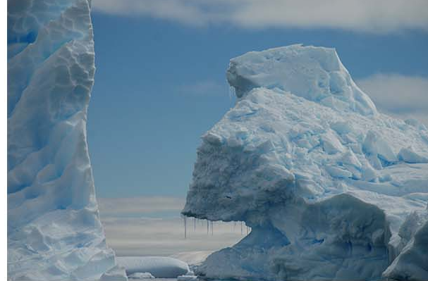 | UC-001 | Icebergs  EX-DISPLAY COPY (1m x 70cm): £199  plus delivery or self-collect | 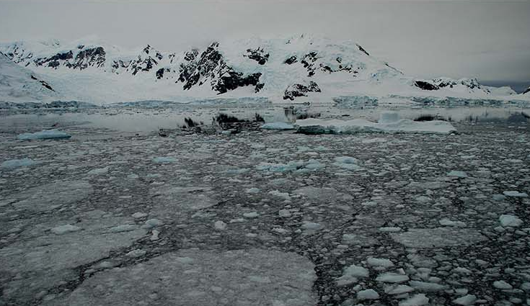 | UC-012 | Pancake Ice  EX-DISPLAY COPY (1m x 70cm): £199  plus delivery or self-collect
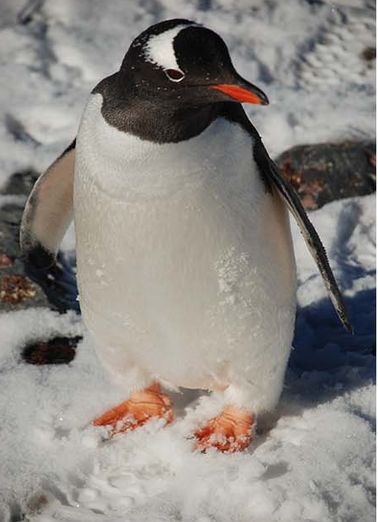 | UC-002 | Gentoo Penguin  EX-DISPLAY COPY (60cm x 40cm): £69 plus delivery or self-collect | 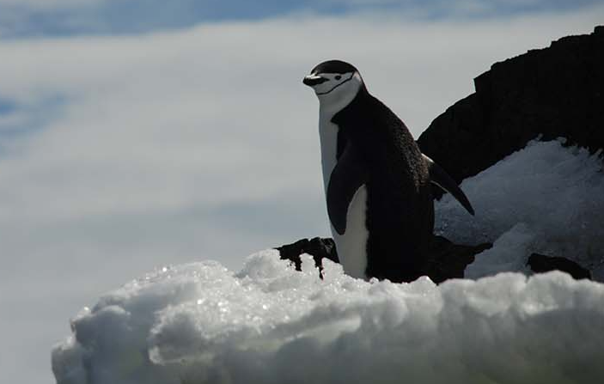 | UC-010 | Chinstrap Penguin  EX-DISPLAY COPY (1m x 70cm): £199 plus delivery or self-collect
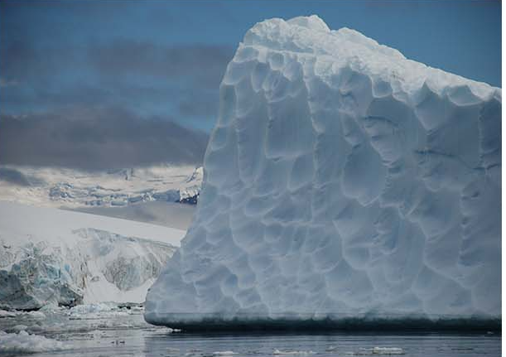 | UC-003 | Golf Ball  EX-DISPLAY COPY (1m x 70cm): £199 plus delivery or self-collect | 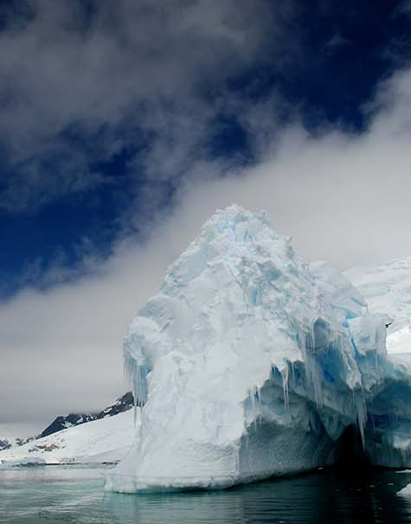 | UC-013 | Ice Maiden’s Cavern  EX-DISPLAY COPY (70cm x 1m): £199 plus delivery or self-collect
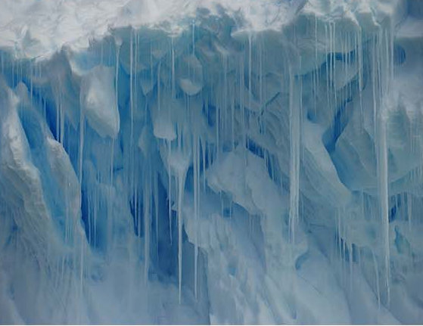 | UC-005 | Stalactites  EX-DISPLAY COPY (70cm x50cm): £79 plus delivery or self-collect | 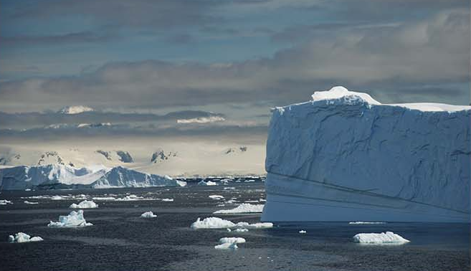 | UC-011 | Frozen Sea of Tranquility  EX-DISPLAY COPY (1m x 70cm): £199 plus delivery or self-collect
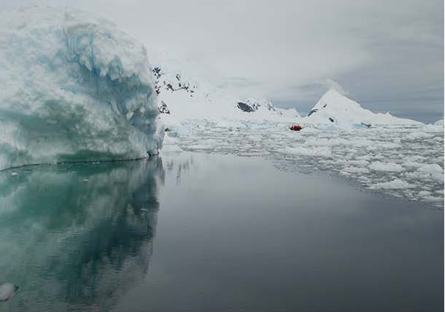 | UC-004 | Mirror of Reason  EX-DISPLAY COPY (1m x 70cm): £199 plus delivery or self-collect | 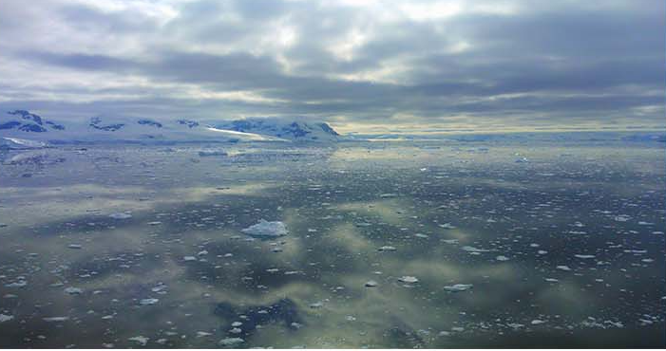 | UC-008 | Heart of Glass  EX-DISPLAY COPY (1m x 70cm): £199 plus delivery or self-collect
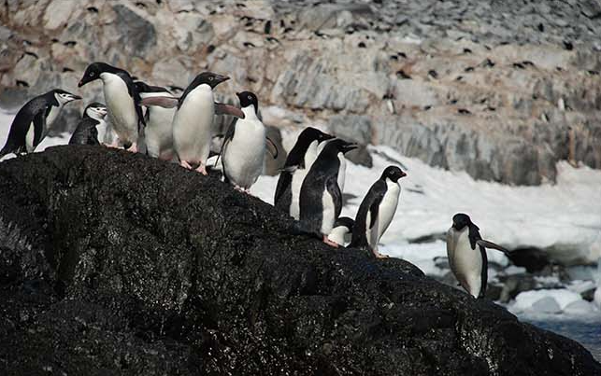 | UC-006 | Penguin Colony  EX-DISPLAY COPY (1m x 70cm): £199 plus delivery or self-collect | 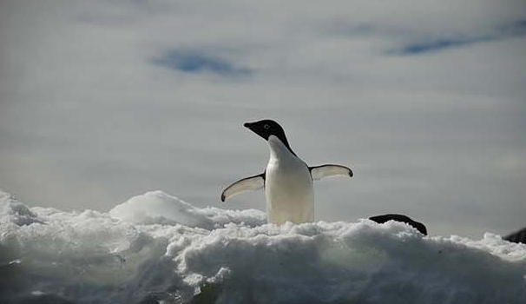 | UC-016 | Adélie Penguin  EX-DISPLAY COPY (1m x 70cm): £199 plus delivery or self-collect
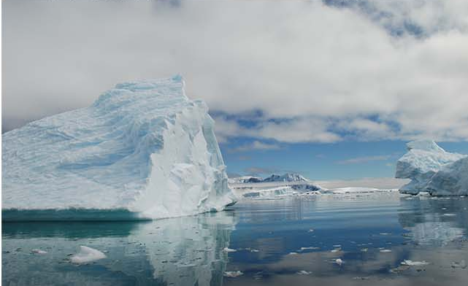 | UC-007 | Why So Blue  EX-DISPLAY COPY (1m x 70cm): £199 plus delivery or self-collect | 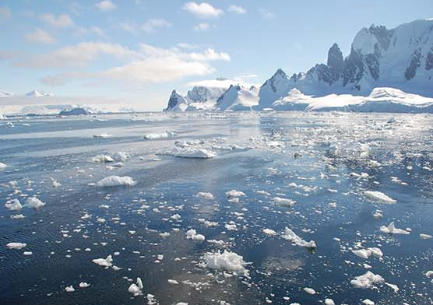 | UC-018 | Bergy Bits and Growlers  EX-DISPLAY COPY (1m x 70cm): £199 plus delivery or self-collect
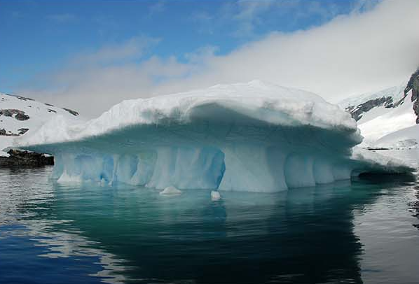 | UC-009 | Temple of Ice  EX-DISPLAY COPY (1m x 70cm): £199 plus delivery or self-collect

